Mod-9: Final Process Summary with Flowchart
Mary Gerdes
CS 500: Introduction to Programming
Southern New Hampshire University
April 3, 2026
Mr. Omar Hamdy

Mod-9: Final Process Summary with Flowchart

Budgeting Application Introduction
For this application, I focused on usability, security, and maintainability. Its main use is to help users track income, manage and categorize expenses, and set savings goals. The system is built using Python with a Flask-based backend and a simple, user-friendly interface.
Development began with a flowchart to map the application’s workflow. It outlined the key steps, including user registration and login, authentication, financial data inputs ( income, expenses, savings goals), data processing and removal, and visualization through a dashboard. This visual model helped with clarity for the program’s logic and guided the module structure for the code.
Fundamental concepts were applied throughout the application. Variables, conditionals, loops, and data structures such as lists and dictionaries were used to manage and process the financial data. For example, loops were used to calculate total incomes, expenses, and percentages, while conditionals were used for the correct handling of user inputs.

Code Structure and OOP
Object-Oriented programming (OOP) was central to this design. The main classes found in the models.py file include User, Income, Expenses, Savings, and SavingsGoal. Each class holds relevant data. The user class handles authentication, token management, and relationships with financial records, while the other class represents the financial transactions linked to the user. Encapsulation was used to secure sensitive data, such as passwords, using hashing methods. Instead of storing plain text passwords, the dedicated methods of set_password and check_password ensure secure handling. Organizing the code into modules kept concerns separated and abstracted. Using this modular structure improved maintainability and scalability. Each component has a specific purpose, making it easier to debug, update, or extend the application. For instance, I added later income and expense histories, which allows for individual record deletion.

Functions, Libraries, and Application Functionality
The application uses both built-in Python libraries and external packages to enhance functionality. Flask provided the framework for routing and API development, while Flask-SQLAlchemy simplifies database interactions through object-relational mapping. The werkzeug.security library is used to generate secure authentication components, flask_basicauth is used to secure the API, and session management uses Flask’s built-in session object to store the user_id after login.
Key features of the application include:
- Secure registration and login with token-based authentication(password hashing)
- Adding and removing income and expenses
- Categorizing expenses
- Setting and updating savings goals
- Calculating income, expense, and remaining balance
- Displaying a pie chart for financial visualization
- Resetting the app to zero to start over
Input validation was implemented to maintain data integrity. Numeric inputs are checked to ensure they are valid and non-negative, and required fields are enforced. This prevents invalid data from entering the system and reduces runtime errors.

Security and Error Handling
Security was a major focus during development. Passwords are securely hashed, and sessions with the hashed passwords allow only authorized users access to their data. This approach protects against unauthorized access and common vulnerabilities.
Input validation also contributes to security by preventing malformed or harmful data from being processed. This reduces the risk of issues such as injection attacks or unexpected behavior. There is also error handling for scenarios such as invalid login credentials and duplicate usernames. Clear error messages guide users and improve overall usability.

Testing and Validation
Testing was conducted through manual unit tests implemented in test.py. These tests verified core functionality, including database setup, session teardown, user signup, and adding and removing income and expenses. The console outputs were confirmed successful operations, providing evidence that the application meets all functional requirements (see test.py below).

Conclusion
This budgeting application uses strong programing fundamentals, effective object-oriented design, and secure coding practices. The modular architecture ensures maintainability and scalability, while integrated libraries enhance both the functionality and user experience. Through careful design, implementation, and testing, this application provides a reliable and user-friendly solution for managing personal finances.

Visio Flowchart and Testing

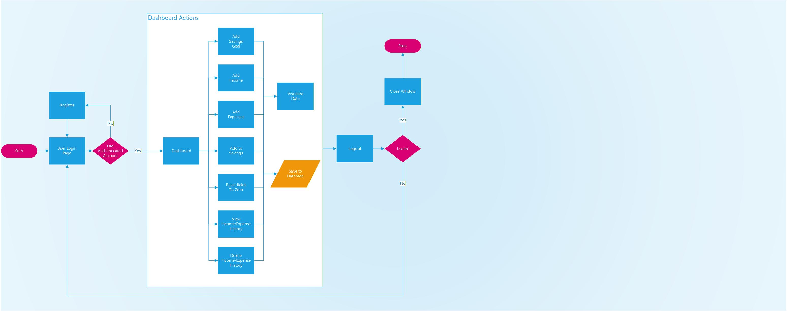
Visio Flowchart
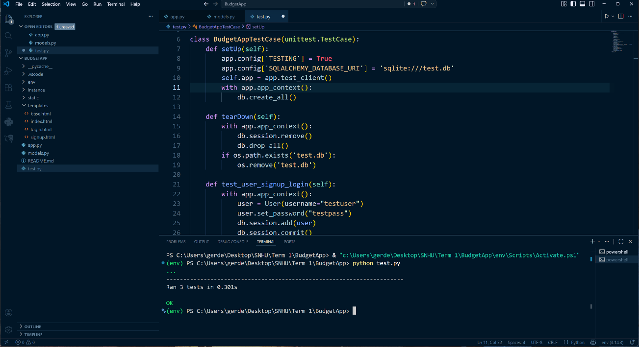
Test.py

